

DYNAMICS TMS

Objectives:
FREIGHT BILL ENTRY

Introduction:
Dynamics TMS Accounting allows users to enter in carrier invoices. This document describes user set up and function.

Freight Bill Entry

When set up to enter freight invoices into TMS, specific TMS users can be assigned access to enter in invoices by carrier.
Go to the User Maintenance Page in System for the corresponding Legal Entity and select an internal user to grant access to the carrier’s view of the invoice transactions.
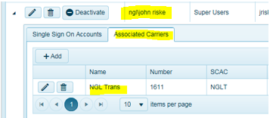
Click on Associated Carriers tab.
Click on Add.
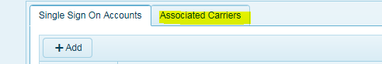
Select the carrier to be associated with this user and select the Accounting Check Box. Do this for every carrier you want to be associated with this TMS user. Note, when adding a new TMS users, this set up can be done upon the creation of the new user.

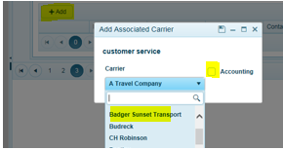
This will now provide access to the web settlement screens and allow this user(s) to enter in carrier freight invoices manually. Note, users will need access to the Settlement Page as part of their Role access.

Settlement Page

To begin entering in carrier freight invoices go to NEXTrack and click on the Settlement Page.
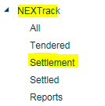
Here you will see a list of all invoices ready to be entered for each carrier that was associated with the TMS user account. A delivery date is required before any transaction will appear here. It’s best to train carriers to insert delivery date into the portal.
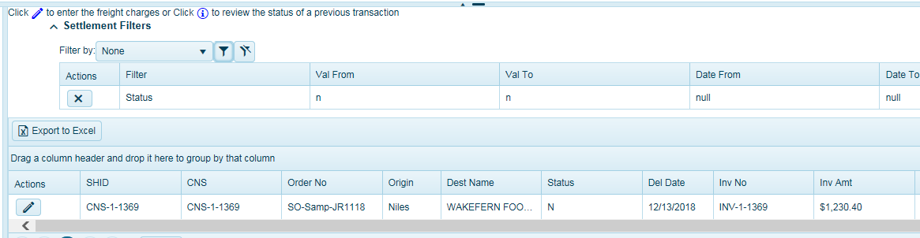
Users can apply filters such as Carrier Name to view carrier specific transactions.
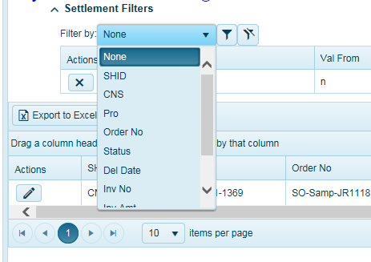

Before entering invoices, it’s best to sort your work by carrier so you can insert carrier invoices carrier by carrier.
Each freight invoice should be associated with a ShipID (CNS number) from TMS and carriers should reference this number on all invoices.
Note, summary invoices are not allowed. If carriers send summary invoices for more than 1 load, user must append a -1, -2 or –A, -B at the end of their invoice entry to make this freight invoice unique.
You can search for the CNS (aka ShipID) load you want to enter in your freight invoice for. Click on the pencil icon to EDIT.
N Status = Are new records waiting for freight bill entry.
PENDING Status = waiting on TMS user to approve entries.
FAILED Status = Are freight bills that have been entered but did not pass the audit function. This requires a TMS user to review this exception.
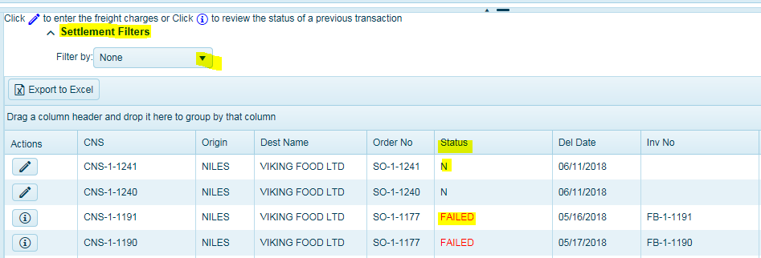

There are two methods for entering Freight Invoices.

1) Quick Edit-
Where Carriers or TMS Users only want to enter the total invoice amount.
Quick Edit
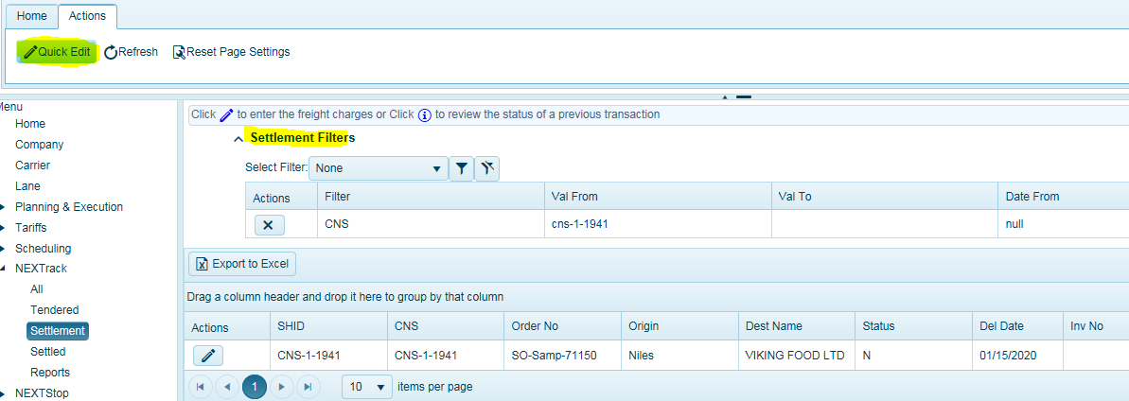
Click on the Quick Edit button in the Actions menu. A dialog box will open.
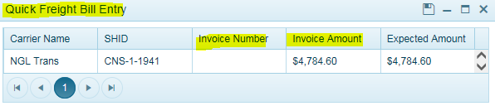
Insert the Invoice Number
Insert the Invoice Amount – This should be the total amount of the invoice including all fees.
Expected Amount- This is what was estimated at booking.
Users can add any number of invoices at one time and when done. Click SAVE.
The system will display a success message for all saved records. Any records not invoiced will remain open and a warning message appear indicating the remaining loads. Click on warning message and it will disappear.
The Status column will indicate the status of each invoice.
N Status = Are new records waiting for freight bill entry.
PENDING Status = waiting on TMS user to approve entries.
FAILED Status = Are freight bills that have been entered but did not pass the company level tolerance audit function. This requires a TMS user to review this exception. Often times it could be a fee has not been inserted on the order. Users should run the Audit report to see the difference and or review the load and perhaps update the load with any missing fees. Then re-run the audit.

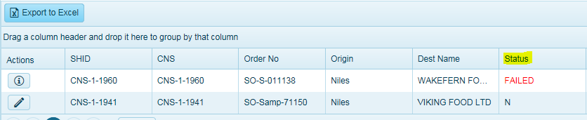
Click on the Information icon for to review the pending/failed freight bill entry. Note you will not be able to edit the freight bill after it has been entered and saved.

2) Detailed Freight Bill Entry-

Where carriers or TMS users can insert invoice and any fees. Administrators must configure the fees in the Carrier Page for each carrier to make fees accessible.
To enter a freight bill, click on the pencil icon in the Actions menu and The Detailed Freight Bill Entry Screen will open.
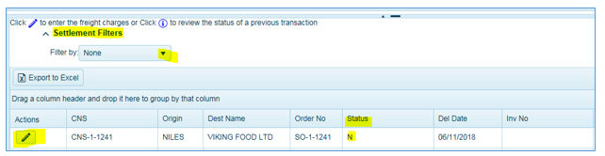
Enter in the carrier Invoice number.
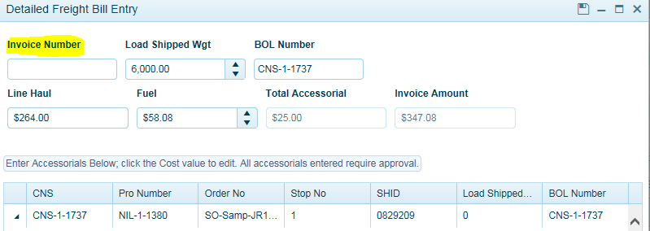
The Line Haul and Fuel will auto populate. If there are any predetermined fees associated with this shipment and if made visible, the fees will open and display here. See Carrier Page to configure fees for selection.
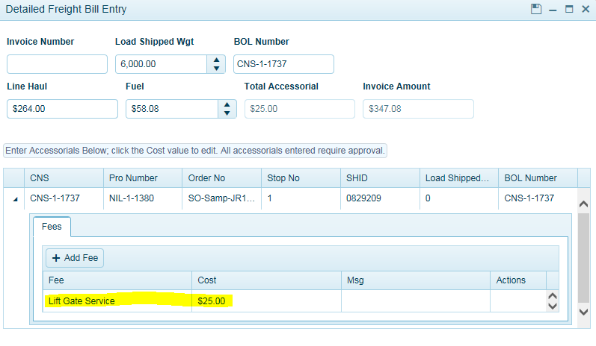
To add another fee, click and expand the black arrow next to the CNS Number (ShipID) and click ADD FEE.
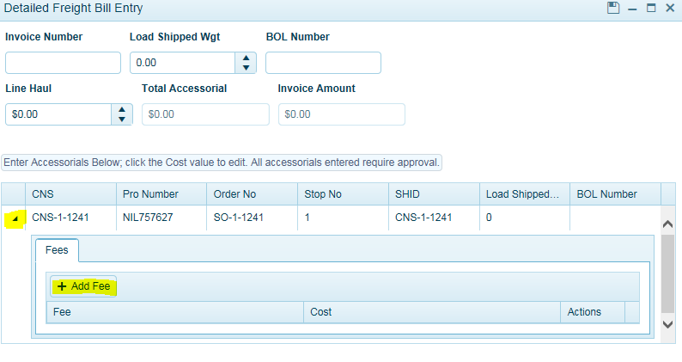
Select your appropriate fee that has been pre-configured and fee amount. Click Add Fee again to add additional fees. If you do not see a fee that you’re trying to enter, contact Logistics or the system admin to add a fee prior to entering this invoice to have it added.
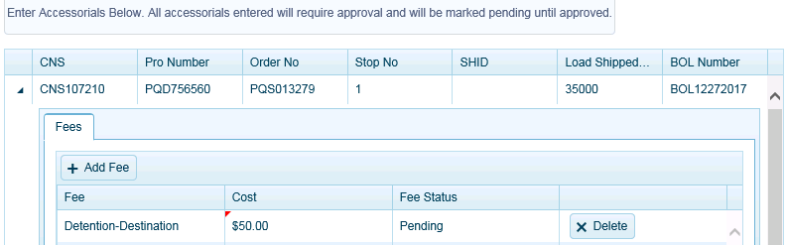
Click SAVE icon when done entering in fees. It is important to note that once fees have been entered and saved, the invoice process is complete.
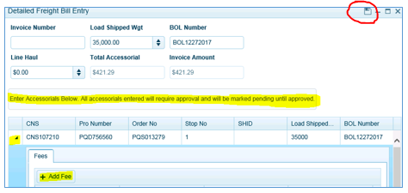
Once all of the freight bills have been entered. Next, you will need to go to the Fee Approval page to ensure any fee entry that is needing approval is approved, audited, and sent to accounting for payment.

Fee Approval Page

The Fee Approval page (Under Load Planning) allows users to review fees entered by carriers or via EDI and require approval for auditing purposes. Fee tolerances can be assigned to each fee and if the fee falls within the tolerance, users can turn on auto approve or manually approve the fee. See Carrier Page for Fee Tolerances set up.
NOTE: If a fee has not been configured as part of the carrier set up (see Carrier Document Fee Tolerance Set Up), the fee value sent by carrier via EDI will not be approved and will need approval before the audit process can be completed. The fee will remain in the Fee Approval screen until approved by TMS user.
When such a fee comes to this page, users should update the carrier fee tolerance setup and configure the fee so the fee will follow the automation of business rules when applied for the next invoice.
Any Web Settlement carrier should contact the logistics department to notify them that a particular fee is not set up, therefore they should not enter in the freight bill until fee has been configured by TMS user.
It is important that users monitor this page and approve as required in order for these transactions to be audited by TMS. Once you have completed the approval process, users should review the AP Freight Bill Audit Screen or run the Auditing Report for any remaining failed audits.

Missing Fee Approval Set Up
When a fee comes into TMS for the first time and it is not configured as part of the carrier’s fee tolerance settings, users can configure the fee for automation so the next time this fee comes in, it will follow the business rules for automation and approval.
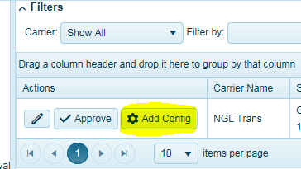
Auto Approve = Check the box to have this fee auto approve based on tolerance settings. Otherwise, users will need to approve this fee next time.
Allow Carrier Updates = Check the box to allow carrier updates (via Portal or EDI) Recommended.
Show Contracted Fees = Check the box to display fees during invoice entry (via Portal). Recommended.

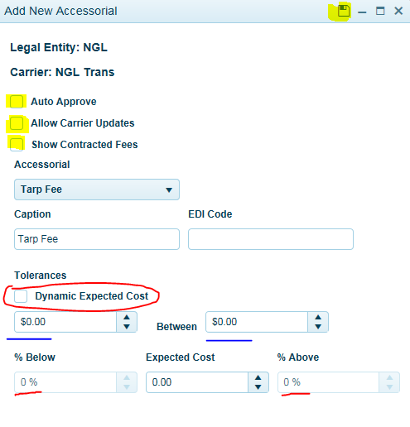
Then select your tolerance settings-Select only one.
BLUE -Insert dollar value low and high. For example, $25 (low) between $100 (high). You accept anything between $25 - $100 for this fee.
RED – Check Dynamic Expected Cost to insert a percentage low and high range. For example, 100% (% below) to 25% (% above)
Or
Set your Expected Cost at $50. Your percentage low set to 20% (which is $50-$10=$40) to 20% above ($50 + $10 = $60) above. This fee expected price range is between $40 - $60.

Go to the Fee Approval Screen and approve any waiting fees entered by a user or carrier. You will need rights to access this page. Click on Edit to change the amount you want to approve or click Approve.
You can filter the data to see fees by carrier etc. Additional filters can be applied. You will see every fee entered by a TMS user, carrier, or EDI for a given load that needs approval in this screen. It might be helpful to group the data by ShipID (CNS Number) to see fees associated to the same ShipID (invoice).
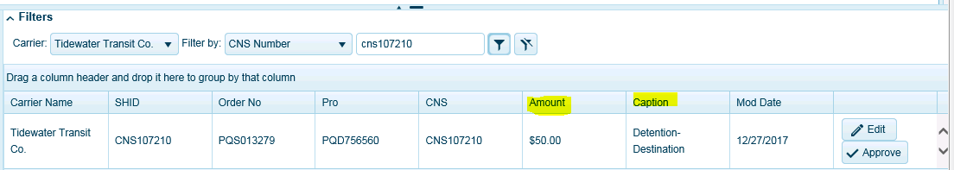
For example:
Filter by: CNS106722
Any of the column headers such as CNS Number by clicking and dragging the header just above its location. If you click on the group label, it will sort ascending / descending if you hit it a second time. The third time will remove the sort.
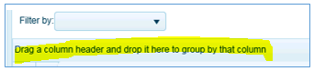
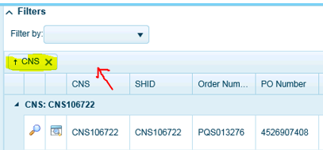
Users should review each fee by carrier and either Approve or Edit the fee.
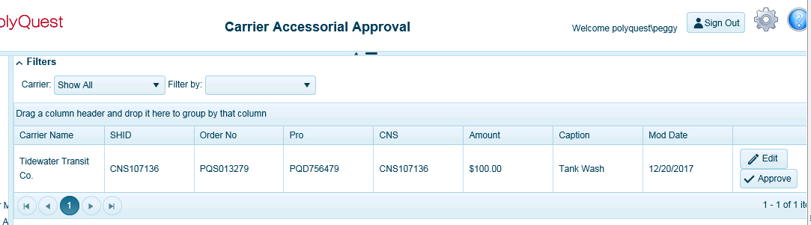
Approve = when users click on Approve, you are agreeing to the amount entered by the carrier. This will update the fee(s) amount in the Revenue Screen and re-calculate and update the carrier cost. Then push this invoice through the audit function.
Edit = User is modifying the carrier fee entry and is approving the lessor or higher amount entered by the carrier. This will update the fee(s) amount in the Revenue Screen and re-calculate the carrier cost. Then push this invoice through the audit function.
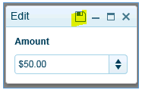
Click Save when done.
The system will display what the carrier entered as a fee value versus what the tendered cost for this predetermined fee.
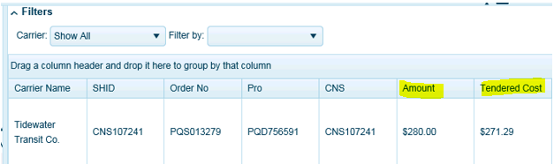
Locked Costs Approval
If the cost box is locked, the system will prompt the user a warning messaging indicating that this is a fee associated with a Locked Cost load (Spot or API carrier) and have been locked to protect from automated updates. All Spot Rate/API loads are “locked” in TMS to prevent automated updates. Users can also see which loads have locked costs by the display box. If checked, Costs are locked.
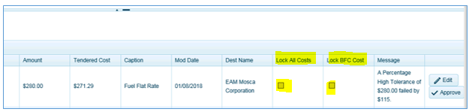
Before any fees can be approved, the system will notify the user that costs are locked and must click OK in order for the system to unlock the carrier costs automatically, allowing the system to insert the fee update to the Revenue Screen in TMS and recalculate costs.
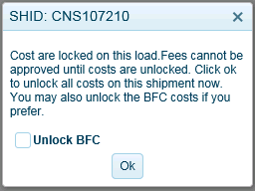
After invoice has been entered. The system will update the status of the invoice based on the system configuration.

There are 3 status workflows:
1) AA = Approved. The system automatically approved the entry, passed audit, and will disappear from the screen. Setting the PExp (Pay Expense workflow to AA-auto approved) in the Load Detail Screen.
There are three ways to view AA statuses:
A) Go to Load Board (Web Client) and apply the filter called Pay Code = AA for a record.
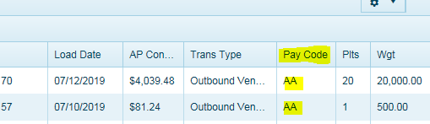
B) Go to the Load Detail Screen (Desktop Client) for this load. The PExp will be in AA status.

C) Go to AP Freight Bill Audit Approval Screen (Web Client) and apply the filter called Pay Code = AA
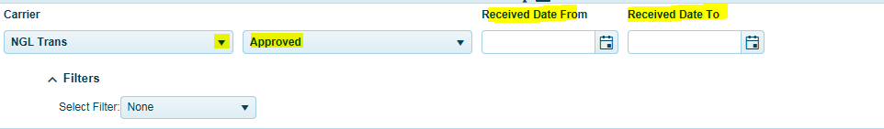
a. Apply your filter by carrier.
b. Select a date range based on invoice date.
c. Use drop down and select Approved to see all approve freight invoices for this date range.

2) PA = Pending Approval. The system accepted carrier web/EDI entry and is waiting on TMS user approval. This transaction will remain in the Pending Approval Page until a user approves them.
There are three ways to view PA statuses:
A) Go to Load Board (Web Client) and apply the filter called Pay Code = PA
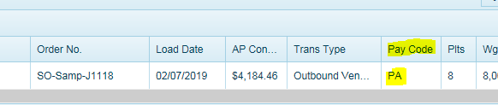
The status will be updated in TMS on all loads that are Pending Approval (PA). Setting the PExp (Pay Expense workflow to PA-Pending Approval) in the Load Detail Screen.
B) Go to the Load Detail Screen (Desktop Client) for this load. The PExp will be in PA status.
C) Go to AP Freight Bill Audit Approval Screen (Web Client)
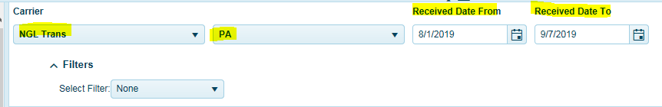
a. Apply your filter by carrier.
b. Select a date range based on invoice date.
c. Use drop down and select PA (Pending Approval) to see all Pending Approval freight invoices
for this date range.
3) M = Match/Failed. The system accepted the freight invoice entry as a matched transaction in TMS but has failed the audit process. All transactions will need to be fixed, re-audited, and pass audit to be set to AA status.
There are three ways to view M status transactions:
A) Go to Load Board (Web Client) and apply the filter called Pay Code = M
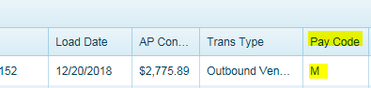
B) Go to the Load Detail Screen (Desktop Client) for this load. The PExp will be in M status.
C) Go to AP Freight Bill Audit Approval Screen (Web Client) and apply the filter called Pay Code = M
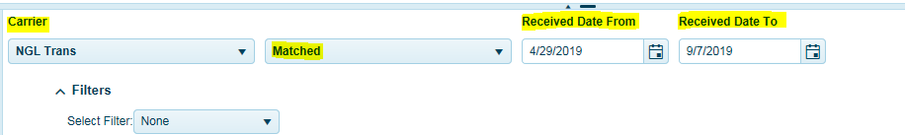
a. Apply your filter by carrier.
b. Select a date range based on invoice date.
c. Use drop down and select M (Matched) to see all failed invoices for this date range.
NOTE: All transactions will need to be in AA status, indicating the invoice passed audit and has been sent to the ERP system for payment.

